**Apps for Flanders on 14th of June, 2013**

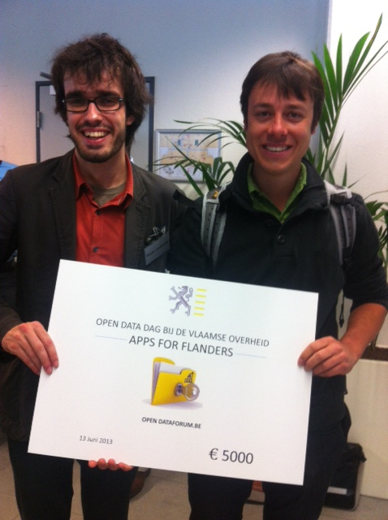

Han Tambuyzer and Ides Bauwens – Winners of Apps for Flanders

“The event was great because we came up with a first draft business idea for the app and got a jury to really be critical on the proposed solution. The award also stimulated us to go on and to put forward a MVP.” Han Tambuyzer, nostalgeo

A jury of experts nominated three winning apps based on the following questions: Is the market for the app well known and how is it achieved? Is the revenue model realistic? What is the economic and social value of the app? How reliable are the open data sets that were used?

1. [nostalgeo](http://www.appsforeurope.eu/case-studies) Winner! nostalgeo is one of our [Case Studies](http://www.appsforeurope.eu/case-studies) and the makers have been invited to our International Business Lounge at Future Everything March 31st 2014.

2. [Pinitag](http://www.pinitag.com/)!  
**The concept:**With Pinitag! It is possible to report grievances or irritations within the public spaces of cities to local councils immediately. This intelligent app decides which city service the pinned and tagged report has to be sent. It won second prize - € 3000.

3. Enerxia  
**Concept:**An app that raises the awareness of citizens about their energy consumption by means of a gamification approach. The game simulates the use of energy in a certain city and stimulates the player to reflect upon the value of sustainable energy and energy saving efforts. They won third prize - € 2000.

For full information visit the event´s web page: <http://lola-ict.org/news/apps4flanders> or have a look at our [blog](http://www.appsforeurope.eu/article/previous-business-lounges).